Analytic and Harmonic Functions
Overview
Does the notion of a derivative of a complex function make sense? If so, how should it be defined and what does it represent? These and similar questions are the focus of this chapter. As you might guess, complex derivatives have a meaningful definition, and many of the standard derivative theorems from from calculus (such as the product rule and chain rule) carry over for complex functions. There are also some interesting applications. But not everything is symmetric. You will learn in this chapter that the mean value theorem for derivatives does not extend to complex functions. In later chapters you will see that differentiable complex functions are, in some sense, much more "differentiable" than differentiable real functions.
Section 3.1 Differentiable and Analytic Functions
Using our imagination, we take our lead from elementary calculus and define the derivative of at , written , by
(3-1) 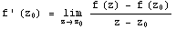,
provided that the limit exists. If it does, we say that the function is differentiable at . If we write , then we can express Equation (3-1) in the form
(3-2) .
If we let and , then we can use the Leibniz's notation for the derivative:
(3-3) .

Extra Example 1. Use the limit definition to find the derivative .
Example 3.1. Use the limit definition to find the derivative of .
Solution. Using Equation (3-1), we have
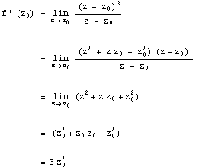
We can drop the subscript on to obtain as a general formula.
Pay careful attention to the complex value in Equation (3-3); the value of the limit must be independent of the manner in which . If we can find two curves that end at along which approaches distinct values, then does not have a limit as and does not have a derivative at . The same observation applies to the limits in Equations (3-2) and (3-1).

Example 3.2. Show that the function is nowhere differentiable.
Solution. We choose two approaches to the point and compute limits of the difference quotients. First, we approach along a line parallel to the x axis by forcing z to be of the form .
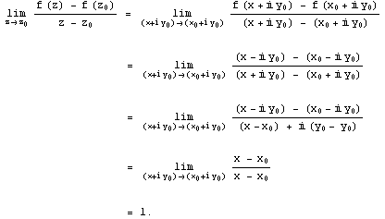
Next, we approach along a line parallel to the y axis by forcing z to be of the form .
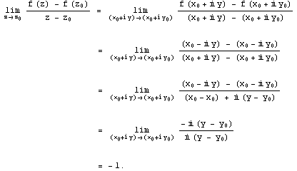
The limits along the two paths are different, so there is no possible value for the right side of Equation (3-1). Therefore is not differentiable at the point , and since was arbitrary, is nowhere differentiable.
Remark 3.1. In Section 2.3 we showed that is continuous for all z. Thus, we have a simple example of a function that is continuous everywhere but differentiable nowhere. Such functions are hard to construct in real variables. In some sense, the complex case has made pathological constructions simpler!

We seldom are interested in studying functions that aren't differentiable, or are differentiable at only a single point. Complex functions that have a derivative at all points in a neighborhood of deserve further study. In Section 7.2 we demonstrate that, if the complex function f(z) can be represented by a Taylor series at , then it must be differentiable in some neighborhood of . Functions that are differentiable in neighborhoods of points are pillars of the complex analysis edifice; we give them a special name, as indicated in the following definition.

Definition 3.1 (Analytic Function). The complex function is analytic at the point provided there is some such that exists for all . In other words, must be differentiable not only at , but also at all points in some -neighborhood of .
If f(z) is analytic at each point in the region R, then we say that f(z) is analytic on R. Again, we have a special term if f(z) is analytic on the whole complex plane.

Definition 3.2 (Entire Function). If f(z) is analytic on the whole complex plane then f(z) is said to be entire.
Points of non analyticity for a function are called singular points. They are important for certain applications in physics and engineering.
Our definition of the derivative for complex functions is formally the same as for real functions and is the natural extension from real variables to complex variables. The basic differentiation formulas are identical to those for real functions, and we obtain the same rules for differentiating powers, sums, products, quotients, and compositions of functions. We can easily establish the proof of the differentiation formulas by using the limit theorems.

The Rules for Differentiation.
Suppose that f(z) and g(z) are differentiable. From Equation (3-2) and the technique exhibited in the solution to Example 3.1 we can establish the following rules, which are virtually identical to those for real-valued functions.
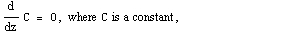
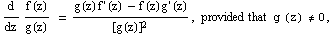

Important particular cases of Equations (3-9) and (3-10), respectively, are

Example 3.3. If we use Equation (3-12) with , and , then we get
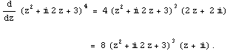
The proofs of the rules given in Equations through (3-10) depend on the validity of extending theorems for real functions to their complex companions. Equation (3-8), for example, relies on Theorem 3.1.

Theorem 3.1. If f(z) is differentiable at then f(z) is continuous at .
Proof. From Equation (3-1), we obtain
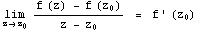.
Using the multiplicative property of limits given by Formula (2-19), we get
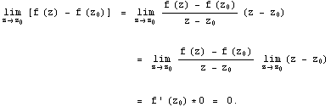
This result implies that , which is equivalent to showing that f(z) is continuous at .
We can establish Equation (3-8) from Theorem 3.1. Letting and using Definition 3.1, we write
.
If we subtract and add the term in the numerator, we get
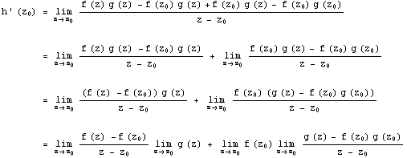
Using the definition of the derivative given by Equation (3-1) and the continuity of , we obtain , which is what we wanted to establish. We leave the proofs of the other rules as exercises.

The rule for differentiating polynomials carries over to the complex case as well. If we let P(z) be a polynomial of degree n, so
,
then mathematical induction, along with Equations (3-5) and (3-7), gives
.
Again, we leave the proof of this result as an exercise.

We can use the differentiation rules as aids in determining when functions are analytic. For example, Equation (3-9) tells us that if are polynomials, then their quotient 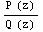 is analytic at all points where . This condition implies that the function is analytic for all . The square root function is more complicated. If , then is analytic at all points except (because is undefined) and at points that lie along the negative x axis. The argument function, and therefore the function f(z) itself, are not continuous at points that lie along the negative x axis
Theorem 3.2, (L'Hôpital's Rule). Assume that f(z) and g(z) are both analytic at . If , , and then
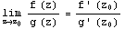.

The Cauchy-Riemann Equations
In Section 3.1 we showed that computing the derivative of complex functions written in a form such as is a rather simple task. But life isn't always so easy. Many times we encounter complex functions written as . For example, suppose we had
(3-13) .
Is there some criterion - perhaps involving the partial derivatives for u(x,y), and v(x,y) - that we can use to determine whether f is differentiable, and if so, to find the value of ?
The answer to this question is yes, thanks to the independent discovery of two important equations by the French mathematician Augustin Louis Cauchy (1789-1857) and the German mathematician Georg Friedrich Bernhard Riemann (1826-1866).
First, let's reconsider the derivative of . As we have stated, the limit given in Equation (3-1) must not depend on how z approaches . We investigate two such approaches: a horizontal approach and a vertical approach to . Recall from our graphical analysis of that the image of a square is a "curvilinear quadrilateral." For convenience, we let the square have vertices , , , and . Then the image points are , , , and , as shown in Figure 3.1.
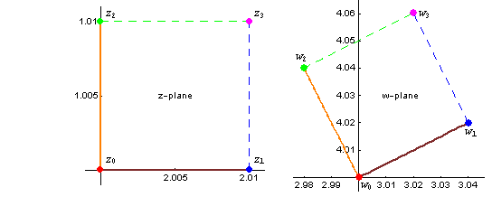
Figure 3.1 The image of a small square with vertex , under the mapping .
We know that f is differentiable, so the limit of the difference quotient 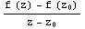 exists no matter how we approach .
Thus we can approximate by using a horizontal increment in z:
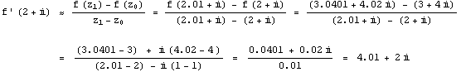
And, we can approximate by using a vertical increment in z:
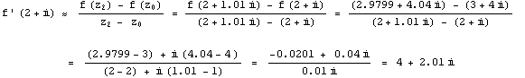
Comparing these two results we see that
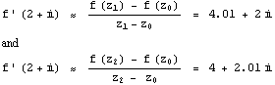
which leads us to speculate that .
These computations lead to the idea of taking limits along the horizontal and vertical directions. When we do so, we get
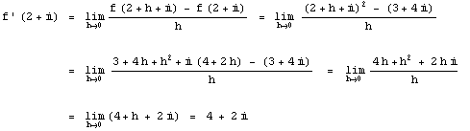
and
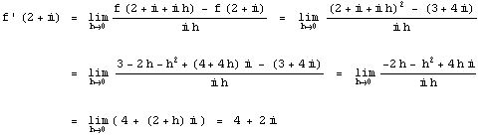
We now generalize this idea by taking limits of an arbitrary differentiable complex function and obtain an important result
Theorem 3.3
is differentiable at the point . Then the partial derivatives of u and v exist at the point , and
(3-14) , and also
(3-15) .
Equating the real and imaginary parts of Equations (3-14) and (3-15) gives
(3-16) and .

Note some of the important implications of this theorem.
(i). If f is differentiable at , then the Cauchy-Riemann Equations (3-16) will be satisfied at , and we can use either either Equation (3-14) or (3-15) to evaluate .
(ii). Taking the contrapositive, if Equations (3-16) are not satisfied at , then we know automatically that f(z) is not differentiable at .
(iii). Even if Equations (3-16) are satisfied at , we cannot necessarily conclude that f is differentiable at .
We now illustrate each of these points.

Example 3.4. We know that is differentiable and that . We also have
.
It is easy to verify that Equations (3-16) are indeed satisfied:
and .
Using Equations (3-14) and (3-15), respectively, to compute gives
, and
,
as expected.
Example 3.5. Show that is nowhere differentiable.
Solution. We have , where and . Thus, for any point , and . The Cauchy-Riemann equations are not satisfied at any point , so we conclude that is nowhere differentiable.
Example 3.6. Show that the function defined by
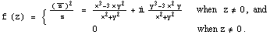
is not differentiable at the point even though the Cauchy-Riemann equations are satisfied at .
Solution. We must use limits to calculate the partial derivatives at (0,0).
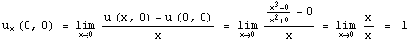,
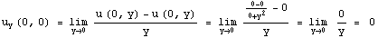,
,
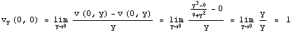.
Thus we have shown that , , ,
Hence the Cauchy-Riemann equations hold at the point (0,0).
We now show that f is not differentiable at . Letting z approach 0 along the x axis gives
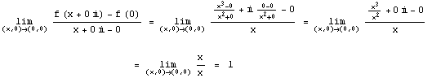
But if we let z approach 0 along the line given by the parametric equations , then
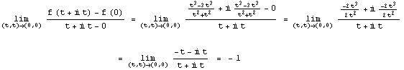
The two limits are distinct, so f is not differentiable at the origin.
Example 3.6 reiterates that the mere satisfaction of the Cauchy-Riemann equations is not sufficient to guarantee the differentiability of a function. The following theorem, however, gives conditions that guarantee the differentiability of f at , so that which we can use Equation (3-14) or (3-15) to compute . They are referred to as the Cauchy-Riemann conditions for differentiability.
Theorem 3.4 (Cauchy-Riemann conditions for differentiability). Let be a continuous function that is defined in some neighborhood of the point . If all the partial derivatives are continuous at the point and if the Cauchy-Riemann equations and hold at , then f(z) is differentiable at and the derivative can be computed with either formula (3-14) or (3-15), i.e.
, or
.
Example 3.7. At the beginning of this section (Equation (3-13)) we defined the function
.
Show that this function is differentiable for all z, and find its derivative.
Solution. We compute and , so the Cauchy-Riemann Equations (3-16), are satisfied. Moreover, are continuous everywhere. By Theorem 3.4, f is differentiable everywhere, and, from Equation (3-14),
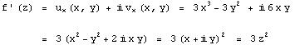
Alternatively, from Equation (3-15),
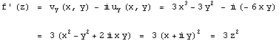
This result isn't surprising because and so the function f is really our old friend .
Extra Example 1. Given .
Show that this function is differentiable for all z, and find its derivative.
Example 3.8. Show that the function is differentiable for all and find its derivative.
Solution. We first write and then compute the partial derivatives.
, and
.
We note that are continuous functions and that the Cauchy-Riemann equations hold for all values of . Hence, using Equation (3-14), we write
.
Aside. Can you guess the "complex" form of ?
Extra Example 2. Show that the function is differentiable for all and find its derivative.
The Cauchy-Riemann conditions are particularly useful in determining the set of points for which a function f is differentiable.

Example 3.9. Show that the function is differentiable at points that lie on the x and y axes but analytic nowhere.
Solution. Recall (Definition 3.1) that when we say a function is analytic at a point we mean that the function is differentiable not only at , but also at every point in some neighborhood of . With this in mind, we proceed to determine where the Cauchy-Riemann equations are satisfied. We write and and compute the partial derivatives:
, , and
, .
Here are continuous, and holds for all . But iff , which is equivalent to . The Cauchy-Riemann equations hold only when , and according to Theorem 3.4, f is differentiable only at points that lie on the coordinate axes. But this means that f is nowhere analytic because any -neighborhood about a point on either axis contains points that are not on those axes.

